Crown and Throne Worship: Rome to Israel Journey
Live global broadcast on February 5, 2018
Panelists: James Nesbit, Pastor Ed Watts, Jamie Fitt, Jon and Jolene Hamill
http://webinars777.com/crown-and-throne-worship-2018/

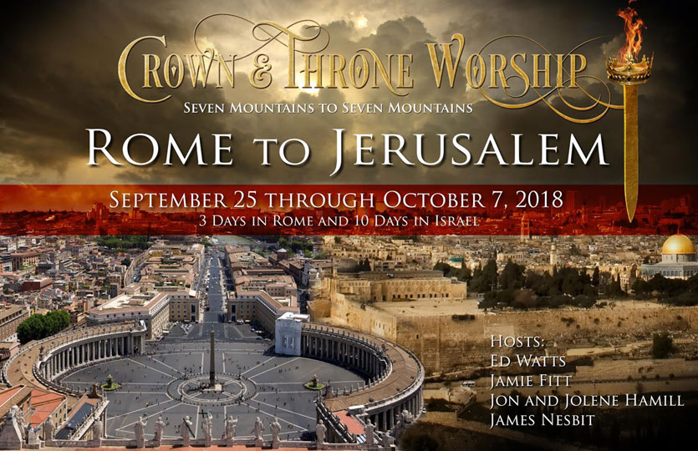

In 70 A.D. the Roman Empire conquered Jerusalem, tore down the 2nd temple (Herod’s Temple) and the Jewish people were exiled to the Nations. Yahweh promised through the Prophets that one day a Jewish Remnant would return to their homeland.
Nearly 1,900 years had passed since their exile, and it seemed absolutely impossible, but in May of 1948 Israel declared itself a sovereign nation. On May 14, 2018 Israel will celebrate its 70th Anniversary of being restored as a nation and back in their land of promise.
Ed Watts believes this 70th anniversary is a prophetic plumb-line that brings clarity to what time it is in the earth. It’s what Acts 3:21 declares; "the time of the restoration of all things."
During September 25 – October 7, 2018, Ed Watts, Jamie Fitt, Jon and Jolene Hamill, and Jamie Fitt are leading the Crown and Throne Worship: Rome to Israel Journey.
You are invited to a free LIVE global broadcast on Monday February 5, 2018 at 3 pm Eastern Time with Ed, Jamie, Jon, Jolene, and James.
CLICK HERE [www.crownandthrone.pagedemo.co] to register
The 7 Hills to 7 Hills - Rome to Jerusalem Journey is a prophetic plumb-line journey that the Father will use to Reclaim, Unlock, Align, and Unleash.
During the LIVE webinar, the panelists will discuss:
- What it means for the Father to Reclaim, Unlock, Align, and Unleash
- ROME TO JERUSALEM 2018
- The Lampstand—From Jerusalem to Rome
- The Lampstand—From Rome to Jerusalem
- Jerusalem, 2018, The Feast of Tabernacles
The 70th Year Anniversary is a huge prophetic threshold that gives clarity to what time it is in human history. It’s time for a remnant to return to Yahweh’s original intent and be prophetically aligned with the City of the Great King - Jerusalem.
What’s in this for Rome? Everything. Seeking God for this prophetic restoration by no means robs Rome; it frees Rome.

On January 28, 2018, James Nesbit wrote:
Rome wasn’t even on my radar previously, but on February 17th of last year (2017), I received this prophetic word from a guy I had never met named Bob Hazelett: "An Italian tour that will land you in the Holy City as well – so you’ll go to the Holy City of Rome and the Holy City of Jerusalem". That was a portion of the second part of word. The first part was, “I saw these angels around you… They were blowing these shofars and had them pointed toward Jerusalem. I feel like there’s even a trip to Israel that God has planned for you that was delayed in the past season, but these angels are preparing the way for you.”
That word was given less than a month before our journey to Israel last year, which was over the top glorious for the 88 people (the same number of keys on a keyboard) Father, handpicked to go with us.
Out of last year’s journey came revelation for this year’s journey. We will spend 3 days in Rome, and 10 days in Israel, worshipping at strategic locations in Rome and throughout the land in Israel.
Join us on this webinar even if you aren’t planning on going on the journey , as Ed Watts,, Jamie Fitt and Jonathan Fitt, Jon Hamill, and myself along with our hosts wade into the revelation Father is releasing concerning his intent for worship over these cities in this hour.
Early in our discussions of this journey last year, Chuck Pierce, released a word that “In this season, the way to Jerusalem is through Rome.”
We don’t understand it all, and Father will not release some revelation until we are on the land.
But those who are excited about what Father, is doing in Israel or just curious, come and spend an hour or so with us Monday February 5th at 3:00 PM
Bless you!
James Nesbit

On January 30, 2018, Jon Hamill wrote:
Here are our insights on Rome to Jerusalem. Much of it is actually taken from the final chapter of our book "The Midnight Cry," which was largely written with this journey at heart. This covers in broad brush strokes the mandate I feel the Lord has given us for the journey.
ROME TO JERUSALEM 2018
Passion, Beauty, History, Destiny—Rome and Jerusalem are uniquely paired among the cities of the earth for all who genuinely seek God, and seek to discover the covenant roots of our faith. The prophetic summons to these two cities in 2018 is beyond words. As you will see, I believe the Spirit of God has invited us to another turning point in history.
Our Crown & Throne Israel tour last year, with renegade worshipers Ed Watts, Jamie Fitt, and James Nesbit, made a defining impact on both our hearts and our world. It is clear that the Spirit of God loves us more though :-) because afterwards, the Lord actually extended our tour—with an unexpected mandate to travel home through Rome.
From the time Jolene and I arrived in Rome, we were surprisingly saturated by God’s presence. Further, every moment became a journey of discovery about God, about ourselves, and about the amazing work He is inviting us to for 2018.
Last year we retraced the steps of King David as he restored the Ark of the Covenant to Jerusalem. This year we are being invited into another journey of recovery. To see His lampstand—and all that it represents—restored to Jerusalem. He is resetting our lampstands and relighting the flame. A burning lamp awakening!
The Lampstand—From Jerusalem to Rome
Near the ancient forum, not far from Rome’s Campidoglio or Capitol Hill, a giant arch was erected to honor Rome’s victory over Jerusalem in 70 AD. The Arch of Titus famously features a sculpted panel depicting the scene of Jewish slaves carrying the Temple menorah into the city.
Remember 2018 is the year of the door. The Arch of Titus represents a doorway by which the Jews entered into all of Europe-unfortunately in shame, prejudice and subjugation. And the Temple menorah, probably lit by Judah Maccabee himself to mark history’s first Hanukkah, was taken captive.
Ancient Roman culture helped to mentor the entire western world in persecuting the Jews. Many of the covenant roots of our faith were simply cut off, replaced with Roman tradition. Pogroms and expulsions ran through the centuries, in all nations, in both Protestant and Catholic expressions. Ultimately this prejudice culminated in the horrors of the shoah, or holocaust.
God is summoning us to the gates. We must do our small part, as empowered by Holy Spirit, in seeing the reversal of this curse.
The Lampstand—From Rome to Jerusalem
While in Rome last April, I believe the Lord showed us that it is now time to apostolically reverse this journey of the menorah, or lampstand. He desires to restore the burning lamp in the depths of our hearts. And He desires to restore the burning lamp of His menorah this year from Rome to Jerusalem.
What does this mean? The lampstand represents God’s covenant and glory. Just as Moses encountered God in a burning bush, the menorah is a burning tree with many branches. But this tree was largely cut off from her covenant roots when replanted in the soil of Rome.
Like the branches of a menorah, the lampstand of our faith branches out to all the world! But it must be centered in Jerusalem, not Rome. We are grafted into God’s covenant with the land and people Israel, not the other way around. I feel the Lord wants to symbolically replant the menorah in the soil of Jerusalem, further reconnecting the branches with the roots of our faith.
Remember Jesus’ parable of the 10 virgins. They awaken at midnight, light their lamps, and go out to meet the Bridegroom. We too are being summoned for a journey-to light our lamps and make a journey. This journey is going to culminate with Israel’s Bridegroom, in a great reunion of the lampstand and tabernacle in the city He eternally calls home.
Jerusalem. 2018. The Feast of Tabernacles.
We are declaring the restoration in Jesus-Yeshua—of our Jewish roots—of our covenant roots.
What’s in this for Rome? Everything. Seeking God for this prophetic restoration by no means robs Rome, it frees Rome. By honoring God’s original intention for His lampstand in Jerusalem, breaches will be healed. And the lampstand of the Lord which genuinely belongs to Rome will immediately become empowered.
That’s the great power of God’s restoration. And I sense prophetically you will see great renewal in both Rome and Jerusalem as a result. A burning lamp awakening!
So friends, lets light our lamps-and from Rome to Jerusalem. Let’s go out to meet the Bridegroom in 2018! He’s standing at the gates even now, waiting for your arrival. Not by might nor by power but by My Spirit, says the Lord of hosts!

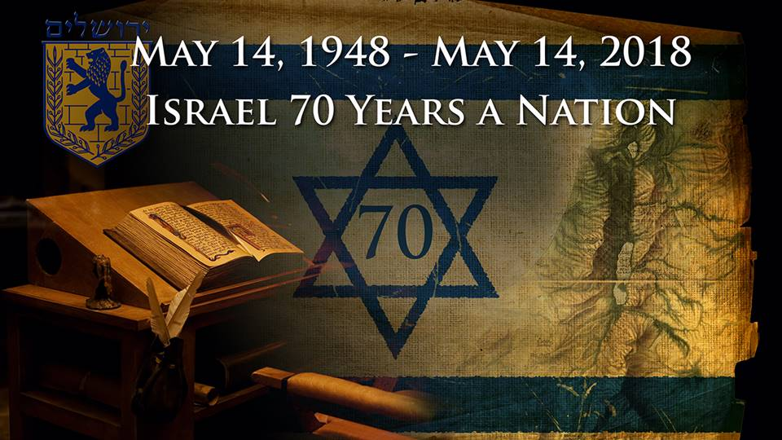
On February 1, 2018, Ed Watts wrote:
The 7 Hills to 7 Hills - Rome to Jerusalem Journey is a prophetic plumb-line journey that the Father will use to Reclaim, Unlock, Align, and Unleash
Reclaim:
- What the Roman Empire & Catholic Church plundered from the Jewish People and the True Church
- The Truth concerning the Feast of Yahweh and His Appointed Times
- Jerusalem’s Menorah - a Prophetic Lamp-stand that releases revelatory light in Israel
Unlock:
- The End-Time Book of Truth/Amen’s (Daniel 12:4)
- The Scrolls of Original Intent for the Nations and the Original 70 Bloodlines
- The Apostolic Mantles that were captured by a Religious Political spirit
- 7/22 Revelation: The 8th & Great Day of the Feast - The Fullness of the Body of Christ
Align:
- We will Prophetically call forth the Alignment of the Body of Christ to Jerusalem and Yahweh’s end-time plan (Joel 3:1-2, Psalm 2)
- We will preform a prophetic act of Aligning the Heads of Government - a Global simultaneous Vav initiative from Capitol Hill in Rome to all 50 State Capitols in the USA and various Capitols in the Nations
- We will Prophetically call forth the alignment of all 50 State Capitols in the USA to the Eternal Capitol - Jerusalem
Unleash:
- A New Sound in Rome and Jerusalem
- A Movement of Messengers with Plumb-line Revelation - "The Finishers" who will Finish the Reformation
- The 3rd Day Priesthood who are able to Carry the Ark of Glory (Jos. 3:1-6)
- A New Era - The Glory Era - "The Period of Restoration of All Things"
The 70th Year Anniversary is a huge prophetic threshold that gives clarity to what time it is in human history. It’s time for a remnant to return to Yahweh’s original intent and be prophetically aligned with the City of the Great King - Jerusalem. In 586 B.C. Jerusalem was conquered, the 1st temple (Solomon’s Temple) was tore down and the Jewish people were exiled to Babylon. They’re 70 year exile was the consequence of worshipping the gods of the 70 Nations around them. Yahweh promised, through the prophet Jeremiah, that a remnant would return after 70 years.
In 70 A.D. the Roman Empire conquered Jerusalem, tore down the 2nd temple (Herod’s Temple) and the Jewish people were exiled to the Nations. Yahweh promised through the Prophets that one day a Jewish Remnant would return to their homeland. Nearly 1,900 years had passed since their exile, and it seemed absolutely impossible, but in May of 1948 Israel declared itself a sovereign nation. On May 14, 2018 Israel will celebrate its 70th Anniversary of being restored as a nation and back in their land of promise. I believe this 70th anniversary is a prophetic plumb-line that brings clarity to what time it is in the earth. It’s what Acts 3:21 declares; "the time of the restoration of all things."
This prophetic journey will be a reclaiming of that which was stolen and plundered by the Roman Empire and the Roman Catholic Church. Amos 3:7 states; "Surely the Lord GOD does nothing unless He reveals His secret counsel to His servants the prophets." There is a Divine Summons being released to an appointed company of prophetic intercessors who discern the times and understand the urgency of the hour and the importance of this assignment.
